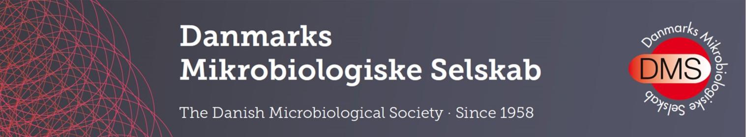

DMS Travel Stipends 2025

The Danish Microbiological Society supports BSc and MSc student at Danish universities for travel as part of their studies.

Travel stipends are given for:

- Travel for working in another laboratory to learn new techniques of relevance to the project.
- Participation in courses outside Denmark, of relevance to the project .
- Field work that is part of the project.

You can apply for travel expenses, costs of living while traveling and bench fees at foreign institutions. A maximum of 20.000 DKK can be applied for, covering costs associated with shorter or longer research stays in national or foreign groups/labs. Grants are awarded for shorter or longer stays in research groups, i.e. not participation in conferences, workshops, meetings or student exchange programs.

The maximum 2 pages long application should include:
- Name, address, and bank information of the applicant.
- A brief description of the project.
- An account of the importance of travel for the project.
- An itemised budget.

In addition to the above, the student should enclose confirmation (e.g., an email) stating that the project supervisor approves of the travel and recommends funding.

Deadline for applications is the 1st of October 2025.

Application should be sent electronically to info@dmselskab.dk. We kindly ask that you use the subject line: “Application for DMS Travel Grant 2025”.

Danish Microbiological Society
C/O CAP Partner
Nordre Fasanvej 113, 2.
DK-2000 Frederiksberg
Denmark
Phone: +45 70 20 03 05
Email: info@dmselskab.dk

